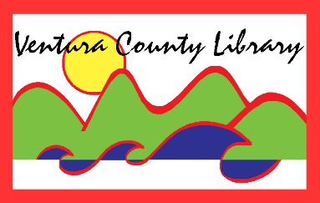

VENTURA COUNTY LIBRARY

5600 Everglades St., Suite A, Ventura, CA 93003

www.vencolibrary.org

FOR IMMEDIATE RELEASE
May 29, 2019

SUBJECT: Lunch at the Library Program at Avenue Library
CONTACT: Irma Morales, Senior City Librarian, (805) 648-2716

DATE: June 17 through July 25, 2019

Avenue Library, one of the twelve library branches of Ventura County Library, in partnership with Ventura Unified School District and Ventura County Public Health Agency is offering free lunches to children and teens on the west side this summer.
The Lunch at the Library program at Avenue Library helps ensure no child or teen in the west side of Ventura goes hungry during their summer school break. The program is open to all children and teens up to 18 years of age. There is no sign-up or income verification necessary. Children and teens are offered a healthy lunch along with fun activities at the Avenue Library.
Irma Morales, Senior City Librarian says, “Avenue Library is an important, recognized community site for free summer activities. We are adding a new component of nutrition along with the summer reading activities by giving out free lunches to children and teens. Good nutrition is important year round, especially when children and teens increase their physical activity during the summer months.”
The Avenue Library Lunch at the Library program begins on Monday, June 17 and continues through Thursday, July 25. Lunches are first come, first served, and are served at 11:30am before the library is open to customers. Fun activities like crafts and story times follow immediately after lunch along with the summer reading program in the afternoon. The Avenue Library is offering free lunches to children and teens on Mondays through Thursdays during this six week period.
The Lunch at the Library program is sponsored by a grant from the California Library Association and in partnership with Ventura Unified School District and the Ventura County Public Health Nutrition Education and Obesity Prevention Program.

"This institution is an equal opportunity provider. The Summer Food Service Program is a program of the United States Department of Agriculture, administered in California by the California Department of Education. Lunch at the Library is a project of the California Library Association, supported in whole or in part by the California State Library with funds from the State of California."

The Avenue Library is located at 606 North Ventura Avenue, Ventura, CA 93001.
See our hours of service at https://www.vencolibrary.org/locations; 805.643.6393.
Ventura County Library: Inspiring our community to explore, discover and connect.
The Ventura County Library is available 24/7 at www.vencolibrary.org.
###

If you would prefer not to receive these event notices in the future, simply reply to this email
with UNSUBSCRIBE in the subject line.

